BABU BANARASI DAS
UNIVERSITY

2026-2027

SCHOOL OF COMPUTER APPLICATIONS
Descriptive Analytics Report

Submitted to: Submitted by:
Miss Monika Rao Sejal
Department: BCA (DS & AI) Roll no: (24)
Date: 9 October 2026 1250258406

Practical 1: Generate a First RetailPulse Report

Related topic: Introduction to IBM Cognos Analytics – Reporting

OBJECTIVE
Navigate the Cognos Analytics Reporting environment and generate a running list report against the RetailPulse Sales
package.

MATERIALS REQUIRED
IBM Cognos Analytics access, RetailPulse Sales package, a personal content folder to save into.

STEP-BY-STEP PROCEDURE
1. Open IBM Cognos Analytics and select New > Report from the welcome screen.
2. Choose the RetailPulse Sales package as the data source when prompted.
3. Pick the List template from the template gallery to start with a simple layout.
4. From the Source tab, drag Region, Product Category, and Sales Amount onto the canvas.
5. Click Run in the toolbar to generate the report and preview live RetailPulse data.
6. Save the report as "RetailPulse – First Sales Report" in your personal folder.

SAMPLE SOLUTION
WHAT A CORRECT RESULT LOOKS LIKE
A three-column list report titled "RetailPulse – First Sales Report" runs successfully, showing Region, Product Category, and
Sales Amount populated with live rows from the RetailPulse Sales package, and reopens correctly from the personal content folder.

EXPECTED OUTCOME
The report canvas displays live RetailPulse rows rather than placeholder text; columns are correctly labeled; the report is
saved and reopens with the same live data connection.
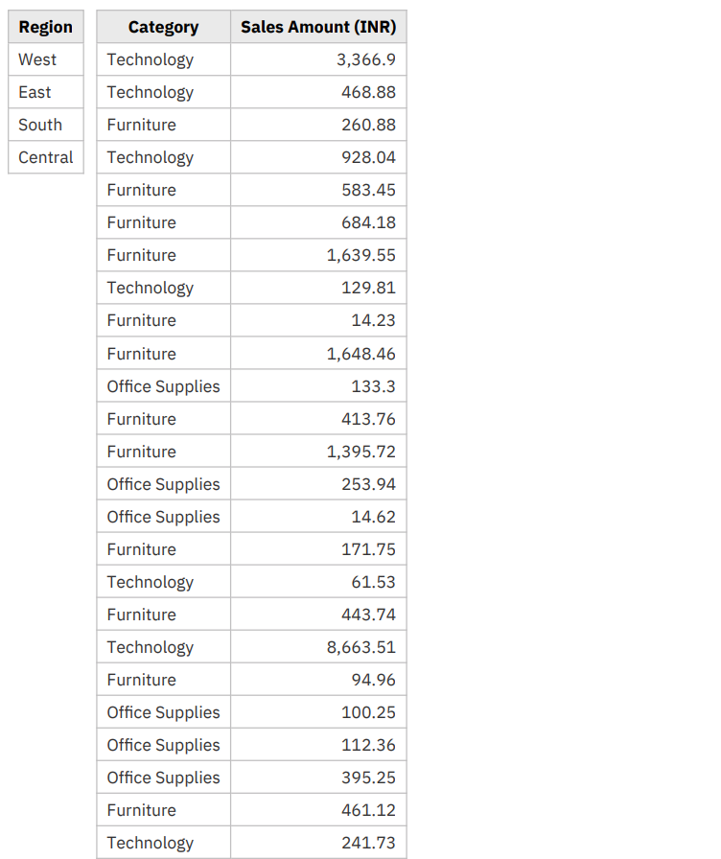
Output of practical 1

Practical 2: Build a Grouped RetailPulse Sales List Report
Related topic: Create List Reports

OBJECTIVE
Construct a list report, group it meaningfully, format its columns, and add a summarizing footer.

MATERIALS REQUIRED
IBM Cognos Analytics access, RetailPulse Sales package, the report saved in Practical 1 (optional starting point).
STEP-BY-STEP PROCEDURE

1. 2. 3. 4. 5. 6. Create a new List report against the RetailPulse Sales package.
Add Region, Store Name, Product Category, Quantity, and Sales Amount as columns.
Group the report by Region, then by Store Name, to build a two-level hierarchy.
Format Sales Amount as currency and right-align all numeric columns.
Add a list footer under Sales Amount using the Total (sum) aggregate function.
Insert a page header with the report title and today's run date, then run and save the report.
SAMPLE SOLUTION

WHAT A CORRECT RESULT LOOKS LIKE

The report groups correctly into Region bands containing nested Store Name bands; Sales Amount displays with currency
formatting and a correctly summed total beneath each Store Name group; the page header shows the title and today's date
on every page.
EXPECTED OUTCOME

Rows are grouped by Region and Store Name with duplicates collapsed correctly; Sales Amount is formatted and right-
aligned; group totals sum correctly; the page header appears on every page.
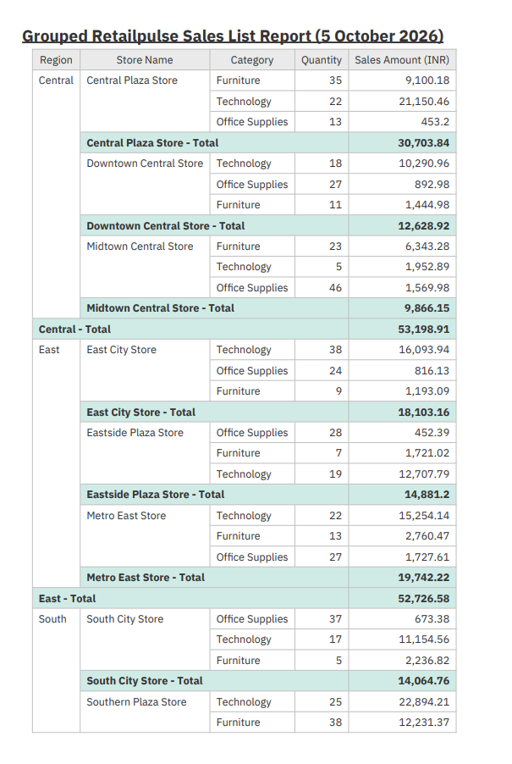
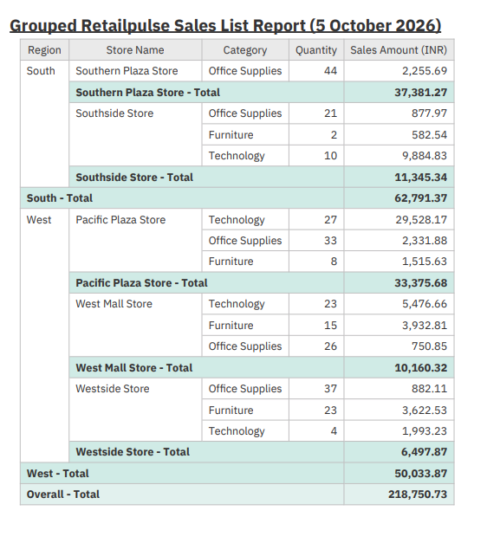
Practical2 output: Grouped Retailpulse sales List Report(5October 2026)

Practical 3: Filter RetailPulse Sales by Region and Date

Related topic: Focus Reports Using Filters

OBJECTIVE

Apply a simple filter and an advanced detail filter to scope a report to a single region and reporting period, then
generalize it with a prompt.
MATERIALS REQUIRED

IBM Cognos Analytics access, the grouped RetailPulse list report from Practical 2.

STEP-BY-STEP PROCEDURE

1. 2. 3. 4. 5. 6. Open the RetailPulse Sales list report built in the previous practical.
Open the Filters pane and add a simple filter: Region =
"North"
.
Add an advanced detail filter combining Sales Date between quarter start and end dates.
Combine both conditions with AND so only North-region, current-quarter rows remain.
Run the report and confirm row counts drop to match the filtered scope.
Convert the Region filter into a prompted filter so other managers can reuse the report.

SAMPLE SOLUTION

WHAT A CORRECT RESULT LOOKS LIKE

After filtering, the report returns only North-region rows within the target quarter; the advanced detail filter expression
correctly joins the date-range condition with AND; converting Region to a prompt lets the same report return South-region
rows when re-run with a different prompt value.

EXPECTED OUTCOME

Only rows matching both filter conditions remain; the row count is visibly smaller than the unfiltered report; the
prompted version correctly returns a different region's data when re-run with a new value.
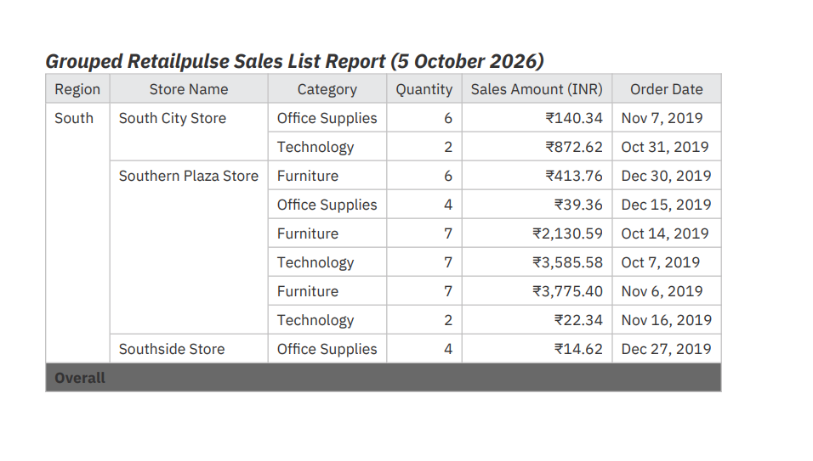
Practical3 Output: Grouped Retailpulse Sales List Report(5October2026)

Practical 4: Build a RetailPulse Region Product Crosstab

Related topic: Create Crosstab Reports

OBJECTIVE

Construct a crosstab report summarizing RetailPulse sales across Region and Product Category with multiple measures
and summary totals.

MATERIALS REQUIRED
IBM Cognos Analytics access, RetailPulse Sales package.

STEP-BY-STEP PROCEDURE

1. 2. 3. 4. 5. 6. Start a new report and choose the Crosstab authoring template.
Drag Region into the row edge and Product Category into the column edge.
Drag Sales Amount into the body of the crosstab to populate the cells.
Add Quantity as a second measure nested beside Sales Amount.
Turn on row and column summary totals to show grand totals for each axis.
Format Sales Amount as currency, run the report, and save it as "RetailPulse Region-Product Crosstab"
.
SAMPLE SOLUTION

WHAT A CORRECT RESULT LOOKS LIKE

The crosstab displays Region as rows and Product Category as columns, with each cell correctly showing summed Sales
Amount and Quantity; row and column grand totals reconcile with the totals visible on the earlier grouped list report.

EXPECTED OUTCOME
Regions and product categories align correctly without misalignment; each cell shows the correct aggregated measures; row and column totals sum correctly; Sales Amount is consistently formatted as currency.
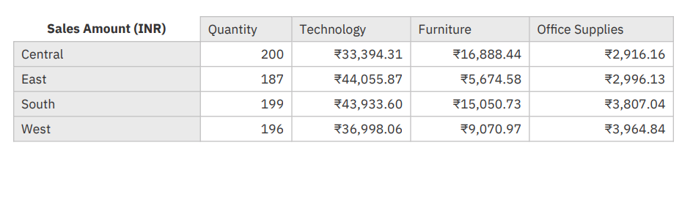Practical4 Output: RetailPulse Region Product Crosstab

Practical 5: Build the RetailPulse Customer Insights Dashboard
Related topic: Build a Dashboard for Customer Insights Visualization

OBJECTIVE

Assemble a dashboard combining a summary card, trend chart, segment breakdown, and a shared filter widget for
RetailPulse customer data.

MATERIALS REQUIRED

IBM Cognos Analytics access, RetailPulse Customers data module.
STEP-BY-STEP PROCEDURE

1. 2. 3. 4. 5. 6. Create a new Dashboard and connect it to the RetailPulse Customers data module.
Add a summary card widget showing total active customers for the selected period.
Add a line chart widget tracking new versus returning customers over time.
Add a bar chart widget breaking down customers by loyalty segment.
Add a Region filter widget and confirm it cross-filters every widget on the canvas.
Arrange the widgets into a clear visual hierarchy, then save the finished dashboard.

SAMPLE SOLUTION

WHAT A CORRECT RESULT LOOKS LIKE

The dashboard displays a summary card, a new-versus-returning trend line, and a loyalty-segment bar chart, all populated
from live RetailPulse customer data; selecting a region in the filter widget updates all three widgets consistently.

EXPECTED OUTCOME

All widgets display live data with no placeholder values; the Region filter widget updates every other widget consistently;
the trend line renders clearly across the full period; layout follows a clear visual hierarchy with no overlaps.
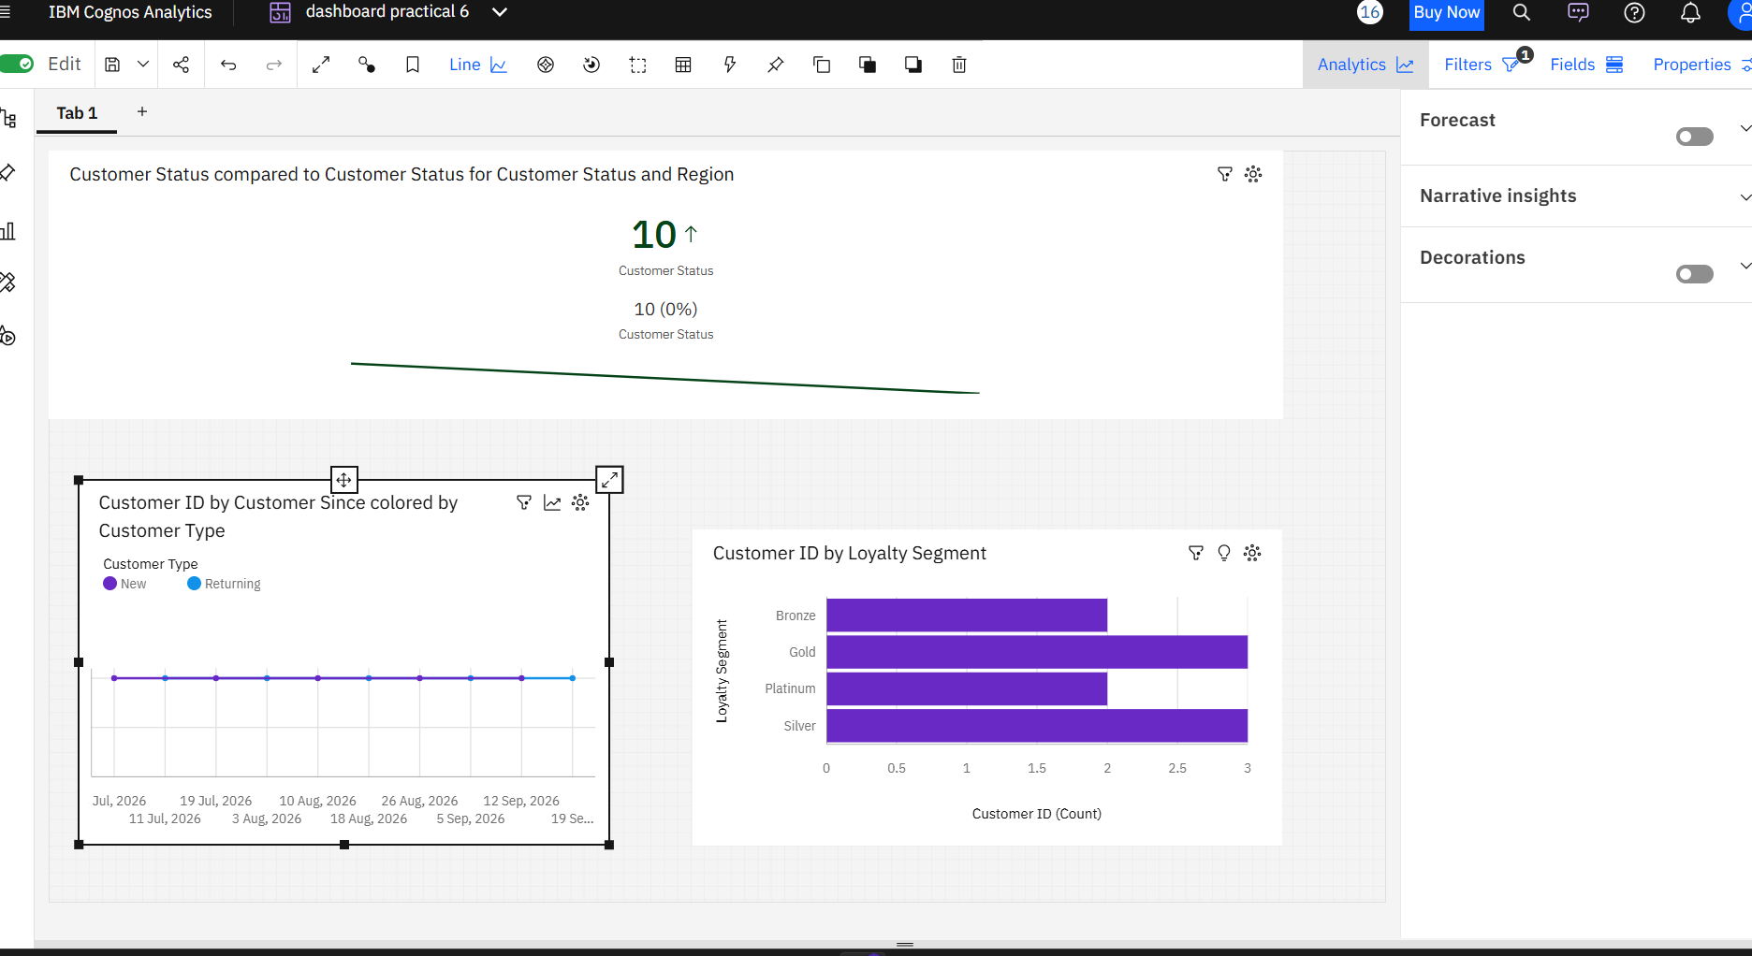
Practical 5 Output: Build the RetailPulse Customer Insights Dashboard

